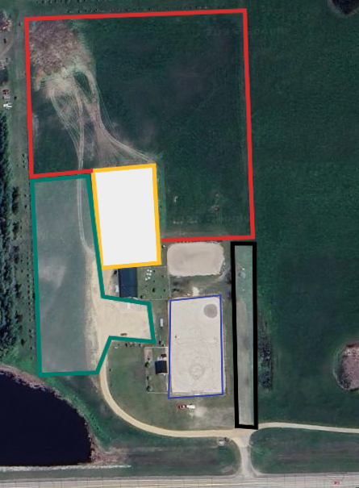
Contestant Parking Area
There will be someone assisting Parking of Trailers
Spectator Parking
Warm Up Arena

